MILESTONE 1: REQUIREMENT ANALYSIS & PLANNING

Auto Ticket Classification using Flow Designer

Problem Statement
The school IT helpdesk receives multiple incident requests daily from students and teachers, such as Wi-Fi issues, projector failures, password problems, and slow computers.
Currently, IT staff manually reviews each request and assigns a category, which is time-consuming and inefficient.
This project automates ticket classification using ServiceNow Flow Designer by analyzing keywords in the incident’s short description and description fields.
Objective
- Automatically classify incidents at the time of creation.
- Reduce manual effort for IT agents.
- Improve ticket routing efficiency.
- Implement a no-code, easily maintainable solution.

PHASE 1: Requirement Analysis & Planning
The school IT helpdesk receives multiple support requests daily from students and teachers related to common issues such as network connectivity, hardware failures, account access problems, and system performance issues.
Currently, IT staff manually review each ticket to:
- Identify the issue type.
- Select the correct category and subcategory.
- Inform the caller about ticket creation.
This manual process is time-consuming, error-prone, and not scalable as the number of requests increases.

Activity : 1 Business Use Case.
Business Requirements
The system must:
- Automatically classify IT tickets based on the issue description.
- Assign both Category and Subcategory without manual intervention.
- Support dependent choice logic between Category and Subcategory.
- Send an automated email notification to the caller upon ticket creation.
- Store ticket information in a structured and standardized format.
Ensure easy maintenance and future scalability.

Activity : 2 Creation of New Update Set.
Navigation Steps :

- Go to All menus → Search for Update set.
- Under System Update Sets → Select Local Update Sets.
- Click the New button on the top right corner of the page.
- Name : Project Update Set.
- State : In progress.
- Application : Global.
- Then Save the Form.
- Under Related links Click on the Make This My Current Set.
- Then the Created Update Set will appear as Current.
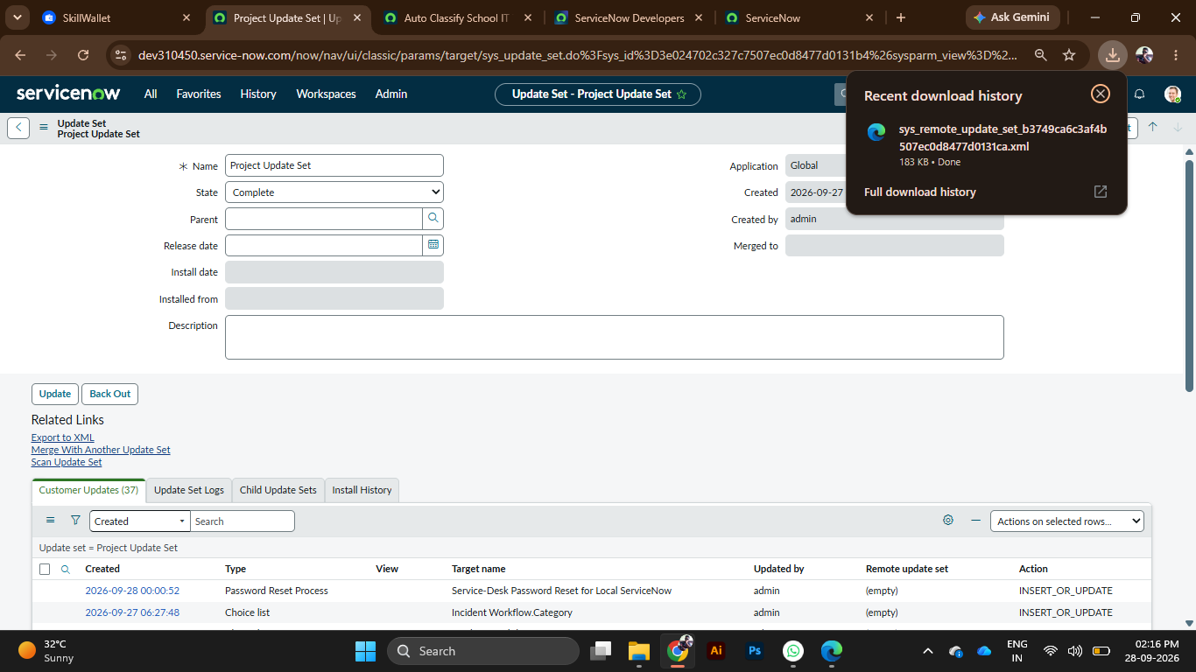

Activity : 3 Navigation steps in Picture View.


